**Task 3 Documentation Compilation**

**1. Introduction**

**1.1 Purpose and Scope**

This document is a technical guide for the HBnB project — a web app for managing users, places, reviews, and amenities. It combines architecture diagrams and notes to help developers understand and build the system effectively.

**1.2 Project Overview**

HBnB lets users sign up, manage places, write reviews, and add amenities. The app follows a layered structure to keep things organized and scalable. This document explains the structure and data flow across the system.

**2. High-Level Architecture**

**2.1 High-Level Package Diagram**

The system is designed using three main layers.  
- Presentation Layer: Handles API routes like user, place, and review.  
- Business Logic Layer: Contains models and validation rules.  
- Persistence Layer: Manages storage and retrieval of data from the database.

The facade as a middle layer between the Presentation and Business Logic layers to simplify interaction.

Figure 1: High-Level Package Diagram

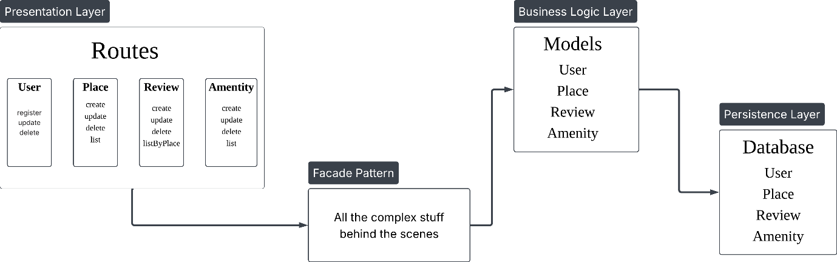

**2.2 Why This Design?**

- The layered structure separates concerns, improving maintainability.  
- The facade reduces complexity by giving the route handlers a simple interface to interact with the business logic.

**3. Business Logic Layer**

**3.1 Detailed Class Diagram**

The Business Logic Layer models core entities and their relationships. This structure is shown in Figure 2.

Figure 2: Business Logic Layer Class Diagram

**3.2 Explanation**

- Entities: User, Place, Review, and Amenity, each with their own attributes and behaviors.  
- Relationships: For example, users create reviews for places, and places have many amenities.  
- Rules: Include validation logic, like required fields or constraints on who can create a review.

**4. API Interaction Flow**

**4.1 Sequence Diagrams for API Calls**

This section shows how requests move through the system for important API actions.

Figure 3: Sequence Diagram

**4.2 Explanation**

Each diagram illustrates:  
- Components: API routes, facade, business logic classes, database.  
- Flow: Step-by-step sequence from request to database action and back.  
- Data movement: Including validations and responses.

**5. Conclusion**

This document gives a clear, simplified view of HBnB’s architecture, logic, and data flows. It helps developers understand how the system works and supports future development.